**Damietta University**

**Faculty of Computers and Artificial Intelligence**

**Advanced System Analysis and Design, 2023/2024**

**[Digital Inventory Management system]**

**Team Members:**

**Salma Mohamed Fatheldin Abdrabou**

**ID: 806146817**

**1 System Request—Digital Inventory Management Project**

**1.1 Project Sponsor**

Salma Mohamed, Assistant Vice, IT Team Leader

**1.2 Business Need**

This project has been initiated to improve the existing manual system. Users maintain details of most system manually which take lot of time effort and cost, so it is not efficient. Instead, we decided to utilize the current system to save time, reduce the cost, and maximize efficiency through exact and current details about inventory levels to enhance user experience. So, will convert our system to digitalized one.

**1.3 Business Requirements**

Using the software and hardware to automate the inventory process. The essential functionalities that the system should possess:

* Determine the amount and type of each certain product.
* ensure the products at optimal level (not too low or too high amount of goods).
* Provide reporting view to know the product state, movement, and delivery time.
* Provide online user support.

**1.4 Business Value**

This project will save time and cost by avoid spending many hours in applying records and providing reports, so we will avoid errors, and lay off some workers. Also, it will increase sales by providing up-to-date information about inventory stock. We expect costumer service improvement and satisfaction through additional online support and all-day available services.

**1.5 Special issues and constraints**

* Proposed system deadline for December 17.
* The system should be available over internet.

**2 Objectives**

* User friendly interface for easy update inventory levels and placing orders with vendors.
* Accuracy in maintaining inventory levels to balance stock.
* Reduce manual efforts.
* Generate reports into inventory performance.

**3 Methodology**

This project will be developed with Agile method, because it provides flexibility needed to change requirements and ensures that the system will aligns closely with expectation.

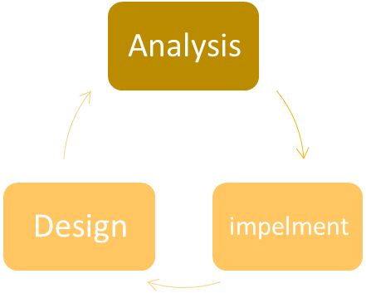

planning

feedback

**4 Requirements**

**4.1 Functional Requirements**

* **Login User:** authorized users only can access the system.
* **Request for reports:** providing reports and dashboards stock levels, and pending orders, …etc.
* **Track Inventory:** to add, delete, and edit inventory items like name, description, and amount.
* **Manage suppliers:** to add and remove suppliers.
* **Support clints:** assist the clints with issues.
* **Alert users:** give notification for users about system updates and stocks.

**4.2 Nonfunctional Requirements**

* **Performance:** the system should respond to user within below 5 seconds.
* **Scalability:** the system should be scalable to handle 50% increase in transactions and database growth without effecting performance.
* **Availability:** the system should be available 24/7.
* **Security:** access and modify sensitive data should be role-based**.**

**6 Context Diagram**

Login Request

Inventory Tracking

**Admin**

Report Request

Suppliers Management

Inventory Tracking

**0**

**Digital Inventory Management system**

Login Request

Report Providing

System issue

**Supplier**

User Alerting

System Login

System Login

Support user

**7 Data Flow Diagram (Level 0 DFD)**

Items Editing/ adding/ removing

**1**

**Track Inventory**

Items Editing/ adding/ removing

Admin preview

Changes Saved

**Admin**

**D1 Inventory DB**

Report generating

Modification Added

**D2 Reports DB**

**Supplier**

Report Retrieval

**2**

**Request for reports**

Report Request

**D3 Suppliers DB**

**3**

**Manage Suppliers**

Suppliers List Update

Addition/ removal to suppliers

**5 Use Case & Narrative Table**

**Digital Inventory Management system**

**Track**

**Inventory**

<<Include>>

<<Include>>

**Login**

**user**

**Request for reports**

<<Extend>>

supplier

Admin

**Manage Suppliers**

|  |  |
| --- | --- |
| **Use Case Name:** Manage Suppliers | **Priority:** High |
| **Actor:** Admin | |
| **Description:** Allows the user to add and remove suppliers from the system. | |
| **Trigger:** User selects ' Manage Suppliers ' option from the system interface. | |
| **Precondition:** User is logged into the system. | |
| **Normal Courses:** 1- System displays existing suppliers.  2- User adds a new supplier.  3- User removes an existing supplier.  4- User confirms changes. | |
| **Alternative courses:**   * User cancels the addition/ removal of a supplier. * User decide not to confirm changes. | |
| **Postcondition:** supplier records in the system are updated based on user actions. | |
| **Exceptions:**   * System fails to update supplier records. | |
| **Summary Inputs:**   * Supplier details. * User decision (addition/ removal confirmation).   **Source:** User input through the system interface. | |
| **Outputs:**   * Updated list of suppliers. * Confirmation Alert.   **Destination:** Suppliers Database | |